Selenium for dynamic web scraping
Quick overview — what Selenium does and when to use it
- Why Selenium? Many websites render content in the browser using JavaScript (AJAX, frameworks like React/Vue). Requests + BeautifulSoup can’t see that dynamic content; Selenium runs a real browser and executes JavaScript so you can access the rendered DOM.
- When not to use it: If the site provides an API, use the API (faster, more reliable). Use Selenium when there’s no API or you need to interact with UI (click buttons, paginate, scroll).
- Ethics & legality: Always check robots.txt and the site’s Terms of Service. Be polite: add delays, rate-limit, cache results, and don’t overload the server.
- Tools used in the example: selenium (v4+), webdriver-manager to auto-install ChromeDriver; WebDriverWait + expected_conditions to wait for elements rather than hard sleeps.
How Selenium Works — Step-by-Step
Here’s what happens behind the scenes:
- Selenium WebDriver launches a real browser (e.g. Chrome).
  - It uses a small background program called a driver (like chromedriver for Chrome).
  - This driver connects Selenium and your browser.
- Selenium sends commands (like “open this URL”, “click this button”, “get this text”) to the browser via the driver.
- The browser executes those actions — exactly as a human would.
- Selenium then retrieves information (like page HTML or text) and sends it back to your Python script.
So Selenium mimics a real human browser session.
That’s why it can handle:
- JavaScript-heavy sites (like Facebook, Twitter, Amazon)
- Button clicks, dropdowns, and scrolling
- Login forms and cookies

Selenium Components
Component | Description
Selenium WebDriver | Core component — controls browsers.
Browser Drivers | Bridge between Selenium and browser. Examples: chromedriver, geckodriver.
Selenium IDE | A browser plugin to record and playback browser actions (for beginners).
Selenium Grid | Runs tests on multiple machines/browsers simultaneously (for large-scale automation).

Typical Workflow in Selenium Scraping
- Launch browser with webdriver.
- Load target URL using driver.get().
- Wait for elements to appear (WebDriverWait + ExpectedConditions).
- Extract data using find_element or find_elements.
- Clean and save data (e.g., to CSV with pandas).
- Close browser with driver.quit().
ExpectedConditions
ExpectedConditions (often imported as expected_conditions or EC) is a collection of ready-made, reusable predicates that you use with WebDriverWait to pause your script until a particular page state is true (element visible, element clickable, title contains text, etc.). They let you write explicit waits so your code acts only after the page is ready.

2) Why use them (intuition)
Web pages are asynchronous: JavaScript may load parts of the page after the HTML is delivered. If you try to click or read an element too early, you’ll get errors or empty text. ExpectedConditions + WebDriverWait ask: “wait until this condition is true (or timeout)” instead of sleeping a fixed amount of time. This makes scripts more reliable and faster.

Common ExpectedConditions you’ll use (and what each means)
- presence_of_element_located(locator) — element exists in the DOM (may be invisible).
- visibility_of_element_located(locator) — element exists and is visible (displayed & has height/width > 0).
- element_to_be_clickable(locator) — visible and enabled (safe to click).
- text_to_be_present_in_element(locator, text) — text appears inside element.
- title_contains(text) / title_is(text) — page title check.
- frame_to_be_available_and_switch_to_it(locator) — wait for iframe, then switch into it.
- alert_is_present() — wait until an alert appears.
- staleness_of(element) — wait until an element is no longer attached to the DOM (useful after navigation).
- url_contains(substr) / url_to_be(url) — check current URL.
- Logical combinators: any_of(...), all_of(...), none_of(...) — combine multiple conditions.

Let’s take a practical Selenium example that demonstrates how these
ExpectedConditions actually work.
We’ll use a demo website — https://the-internet.herokuapp.com —
(it’s built for Selenium testing, so it’s safe to automate).

🧠 Example Goal
We’ll open a page, wait for:
- The title to contain text.
- An element to appear (presence_of_element_located).
- The element to become visible and clickable.
- Then we’ll click it and confirm that the new page loaded.

✅ Full Working Code Example
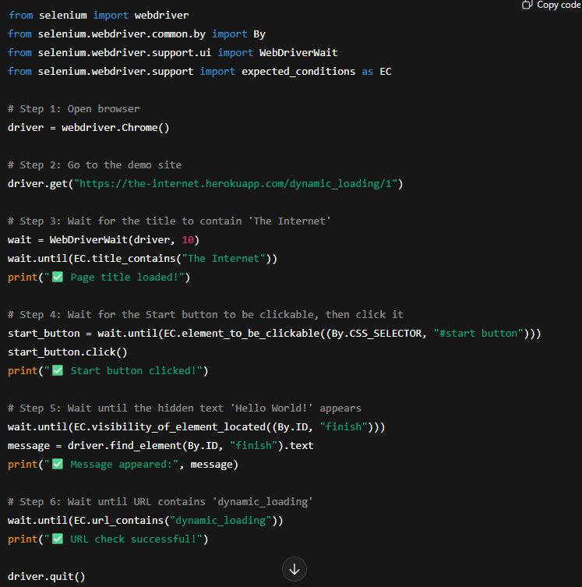

Step-by-step explanation
Step | Condition used | Meaning
1 | title_contains("The Internet") | Wait until the page’s <title> contains this text.
2 | element_to_be_clickable((By.CSS_SELECTOR, "#start button")) | Wait until the “Start” button exists, is visible, and is enabled.
3 | visibility_of_element_located((By.ID, "finish")) | Wait until the hidden <div id="finish"> becomes visible after the load finishes.
4 | url_contains("dynamic_loading") | Ensures the current URL matches what we expect.

What are Locators in Selenium?
When Selenium opens a web page, it “sees” the page structure in HTML.
Locators are instructions that tell Selenium how to find a specific element (like a button, text box, or link) inside that HTML.
Example HTML snippet:
<input type="text" id="username" name="user" class="form-control" placeholder="Enter your name">
When you want Selenium to type inside that input box, you need to tell it which one — that’s where locators come in.
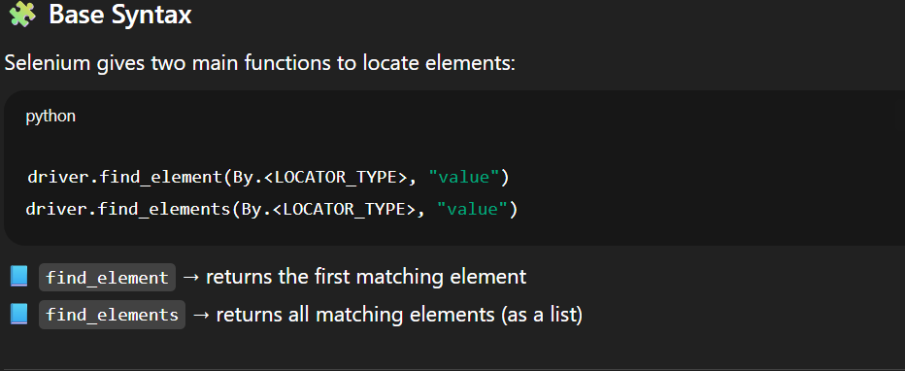

Common Locator Types in Selenium
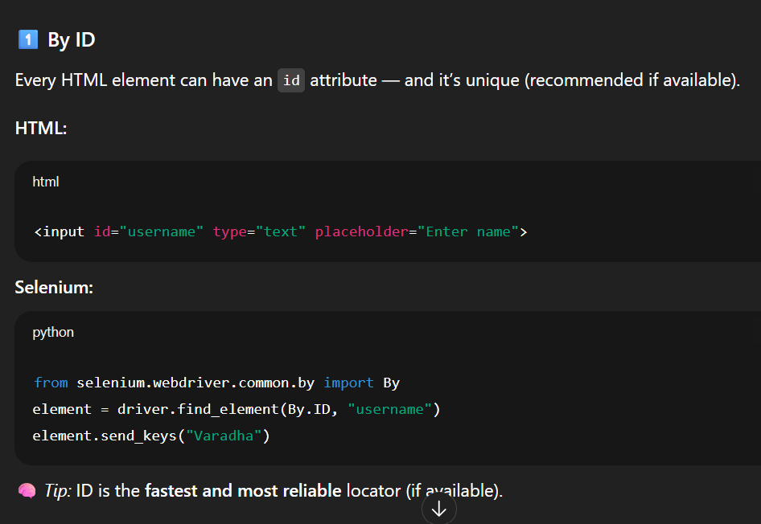

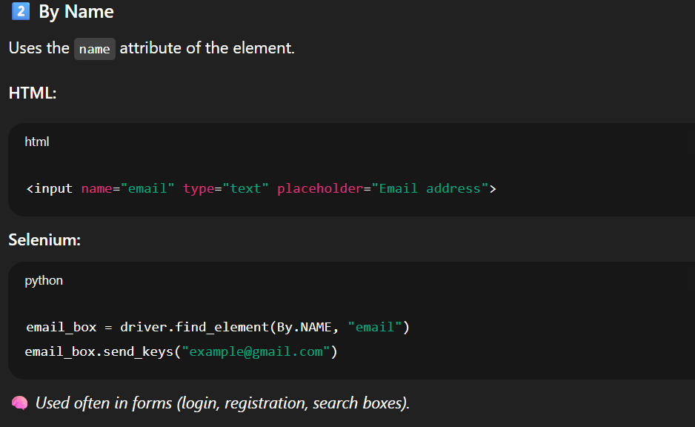
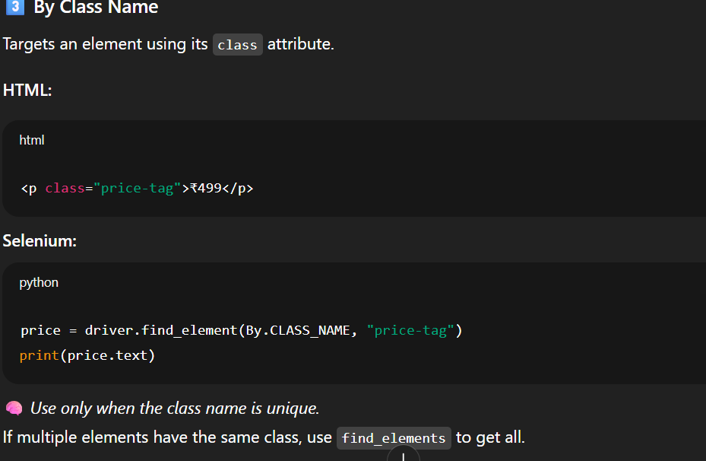
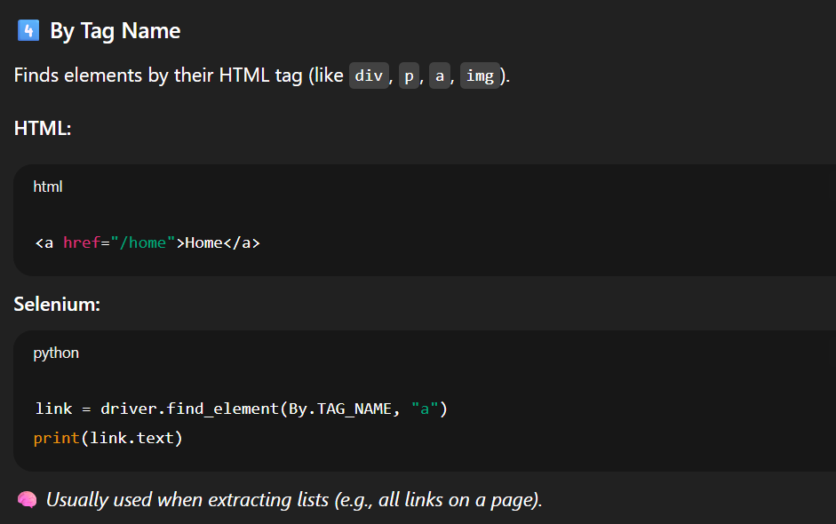
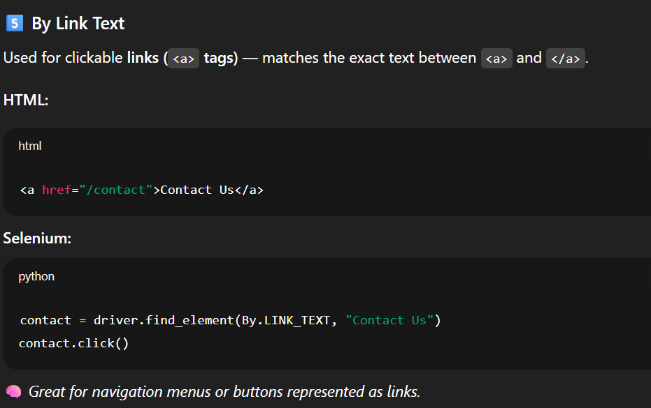

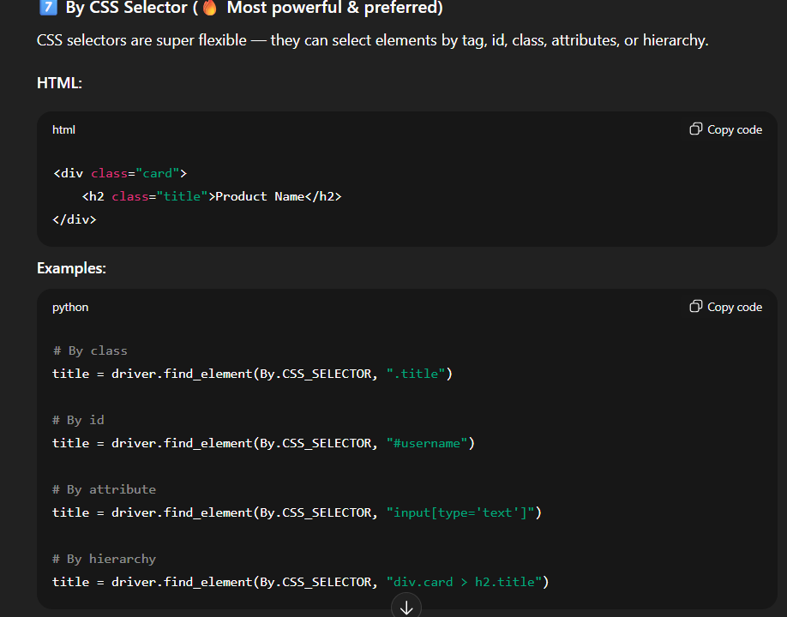

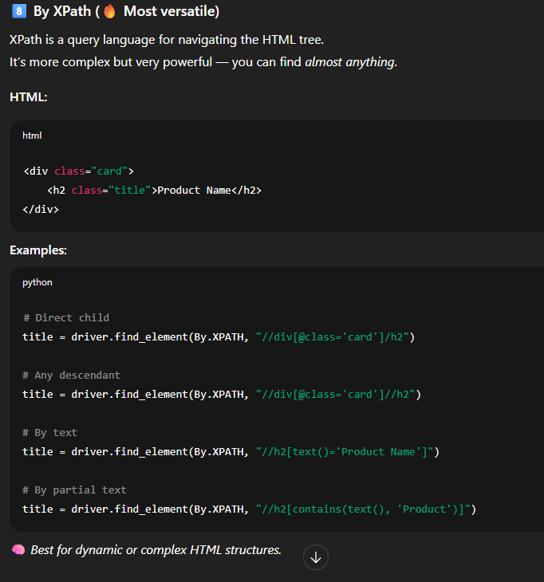

Real Example: Using Locators on a Website
👉 Website: https://www.wikipedia.org
HTML snippet (for the search box)
<input type="search" id="searchInput" name="search" placeholder="Search Wikipedia">
Selenium code:
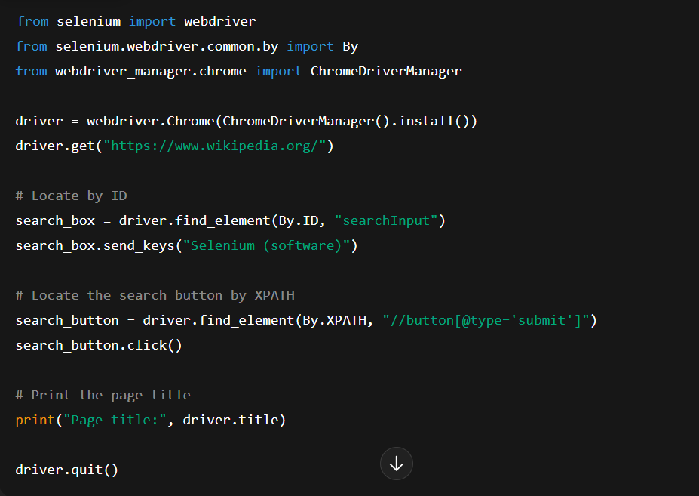

What happened here:
- Selenium opened Wikipedia.
- Found the search box by its id attribute.
- Typed text into it.
- Found the search button via XPath and clicked it.
- Printed the resulting page title.

Locator Type | Example | Best Use
By.ID | driver.find_element(By.ID, "username") | Fastest, when id is unique
By.NAME | driver.find_element(By.NAME, "email") | For form fields
By.CLASS_NAME | driver.find_element(By.CLASS_NAME, "price") | When class is unique
By.TAG_NAME | driver.find_element(By.TAG_NAME, "a") | For lists of tags (like links/images)
By.LINK_TEXT | driver.find_element(By.LINK_TEXT, "Home") | For navigation links
By.PARTIAL_LINK_TEXT | driver.find_element(By.PARTIAL_LINK_TEXT, "Contact") | For long link names
By.CSS_SELECTOR | driver.find_element(By.CSS_SELECTOR, ".card > h2") | Fast, flexible, reliable
By.XPATH | driver.find_element(By.XPATH, "//div[@class='card']//h2") | Powerful, for complex structures

1) selenium (v4+)
What it is: a library that automates a real browser (Chrome, Firefox, Edge, etc.). It drives the browser just like a human: loading pages, clicking buttons, filling forms, executing JavaScript, reading the rendered HTML.
Main concepts / components
- WebDriver — the object that controls a browser instance (e.g., webdriver.Chrome()).
- WebElement — represents one node in the rendered page (e.g., a button or paragraph). You interact with them (.click(), .text, .get_attribute()).
- By — set of locator strategies (By.CSS_SELECTOR, By.XPATH, By.ID, etc.) used to find elements.
- Options — configure browser start (headless, window size, user-agent).
- Actions / Keys — simulate keyboard/mouse advanced input.
Why use it: it executes JavaScript and interacts with dynamic pages that plain HTTP requests can’t see.

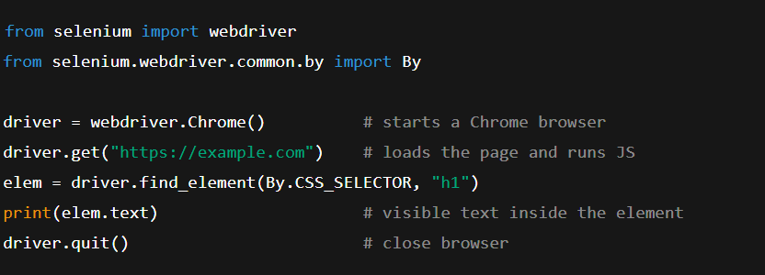

Beginner tips
- Always quit() to free resources.
- Use explicit waits (see below) instead of fixed sleep().
- Prefer CSS selectors (faster/readable) unless XPath is required.

2) webdriver-manager
What it is: a helper library that automatically downloads and manages the correct browser driver binary (e.g., chromedriver) for your installed browser version.
Why it matters: Selenium needs a driver (like chromedriver) that matches your browser version. Installing and updating drivers manually is annoying — webdriver-manager automates that.
How you use it (Python example)
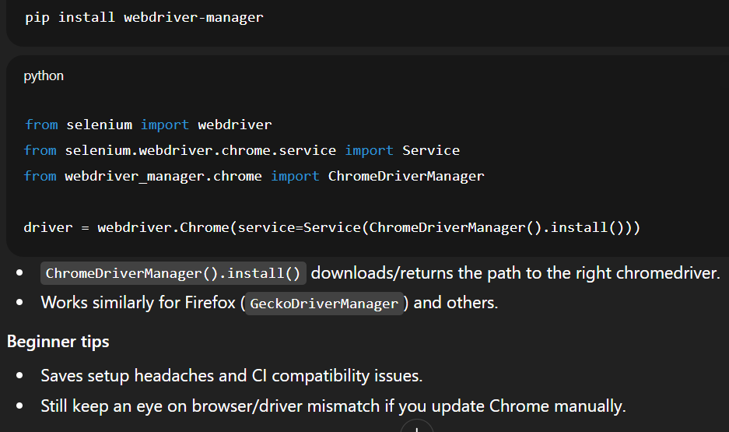

3) WebDriverWait
What it is: a tool for explicit waits — it pauses execution until a condition is true (like an element becomes present or clickable), or until timeout.
Why use it: pages often load content asynchronously. Using WebDriverWait avoids brittle time.sleep() and makes scrapers robust and faster.
Key ideas
- You set a maximum timeout (e.g., 10 seconds).
- WebDriverWait checks repeatedly (polling) until the expected condition passes or timeout occurs.
Usage example
from selenium.webdriver.support.ui import WebDriverWait

wait = WebDriverWait(driver, 10) # wait up to 10 seconds

4) expected_conditions (a.k.a. EC)
What it is: a collection of common conditions you can wait for with WebDriverWait. They encapsulate checks like “element is visible” or “element is clickable”.
Common conditions
- presence_of_element_located((By.CSS_SELECTOR, selector)) — element exists in DOM (may be invisible).
- visibility_of_element_located((By.CSS_SELECTOR, selector)) — exists and visible to user.
- element_to_be_clickable((By.CSS_SELECTOR, selector)) — visible and enabled.
- text_to_be_present_in_element((By.CSS_SELECTOR, selector), "text") — waits until element contains text.
- presence_of_all_elements_located(...) — finds multiple elements.
- staleness_of(element) — waits until a previously found element is removed/changed (useful after page refresh).

1) What is an XPath?
XPath is a language to navigate the structure of an XML/HTML document and select nodes (elements, attributes, text).
Example XPath expressions return element nodes like <div>, <input>, <a>, etc.

2) Absolute XPath
Definition: an XPath that starts at the root of the document and follows the exact path down to the target node.
Syntax: starts with a single slash /
Example (generic):
/html/body/div[2]/div[1]/form/input[1]
Concrete HTML
<html>
<body>
<div>
<p>Intro</p>
</div>
<div>
<div>
<form>
<input type="search" id="searchInput" name="search" />
</form>
</div>
</div>
</body>
</html>
Absolute XPath to the input (one possible full path):
/html/body/div[2]/div/form/input
Selenium usage
driver.find_element(By.XPATH, "/html/body/div[2]/div/form/input")
Pros
- Explicit and unambiguous when the page structure is fixed.
- Easy to understand when you want the exact tree path.
Cons
- Very brittle — any change in document structure (extra wrapper, another div) breaks it.
- Hard to maintain for large/complex pages.

3) Relative XPath
Definition: an XPath that starts from anywhere (not necessarily the root) and finds nodes based on attributes, text, or relative relationships.
Syntax: starts with // (meaning search anywhere in the document) or . for current node.
Example (generic):
//input[@id='searchInput']
Same concrete HTML — relative XPath to the input
//input[@id='searchInput']
Selenium usage
driver.find_element(By.XPATH, "//input[@id='searchInput']")
Pros
- Robust — less likely to break when page structure changes.
- Shorter and easier to write using attributes, classes, text, partial matches.
- Very flexible (can use functions like contains(), starts-with(), text()).
Cons
- If poorly written (too generic) it can match multiple elements — then you need indexing or more specific predicates.

4) Useful relative XPath patterns and examples
Assume HTML:
<div class="product">
<h2 class="title">Red Shoes</h2>
<span class="price">$29</span>
<a href="/buy" class="btn">Buy</a>
</div>
- By attribute:
- //h2[@class='title']
- Using contains() (partial match, handy for dynamic classes):
//div[contains(@class,'prod')]

